**Migration 2010 to 2013**

Table of Contents

1 Known Issues 2

1.1 SQL Database version and .Net Framework Issue. 2

1.2 Users Report for Active Directory Users 2

1.3 Site Template Issue 3

1.4 Do you know how to identify customizations on SharePoint webs? 5

1.5 How to deploy the imported solutions to the new site collection? 6

1.6 Inform staff members that you are about to perform a migration 6

1.7 Don't Forget to lock the SharePoint Content Database before making a backup? 7

1.8 check for errors after the migration process 8

2 Pre-Migration Analysis 9

3 Checklist 9

4 Questions 9

5 Migrate Static Configuration 10

6 Migrate Custom Solution 10

6.1 Approach 1: Upgrade SharePoint 2010 solution in visual studio. 10

6.2 Approach 2 11

6.3 Some Caveats 19

7 Migrating Custom WSP Solutions 19

8 Sandbox Solutions 20

9 Fabulous 40 templates in SharePoint 2013 21

10 Master pages and CSS files 21

11 Themes 21

12 Migrate OOTB features 21

13 How to troubleshoot issues related to the migration of Content DB 37

# Known Issues

## SQL Database version and .Net Framework Issue.

I had faced this issue while content DB restores operation. Make sure source and destination SQL have the same version. SQL does not allow the database to restore from higher version to lower version. You can find perfect version detail using this command. “select @@version”

<https://www.youtube.com/watch?v=d2SE46xaKYE>

I had faced this issue while SQL server installation. SQL server 2012 r2 require .net framework 3.5. It does not work even we have .net framework 4.5. It shows **Netfx 3**

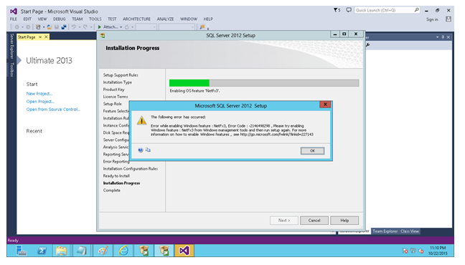

## Users Report for Active Directory Users

SharePoint 2013 foundation version does not support user profile service, so we could not find any AD user.

<https://foundationsync.codeplex.com/>

[http://blog.karstein-consulting.com/2014/02/18/SharePoint-2013-people-picker-error-sorry-were-having-trouble-reaching-the-server/](http://blog.karstein-consulting.com/2014/02/18/sharepoint-2013-people-picker-error-sorry-were-having-trouble-reaching-the-server/)

## Site Template Issue

Not Applicable: Do you know that you need to migrate 'custom site template' before the upgrade to SharePoint 2013 UI?

If you have “custom site template” for your site, you can’t upgrade your site to the SharePoint 2013 UI unless you have a site template with the same name ready for new UI.

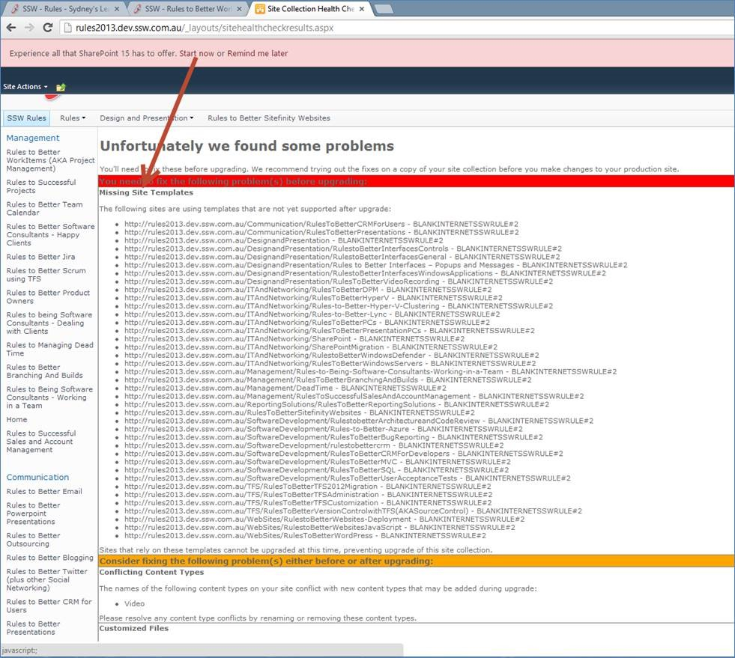

Figure: SharePoint will show you an error “Missing Site Templates” that prevents you from upgrading

​

To fix this issue

1. Upgrade your site template’s content files and definition XML file to SharePoint 2013 (refer to SharePoint 2013 default site template for details).
2. Package the site template’s **content**files to map location “**{SharePointRoot}\Template\SiteTemplate**”.

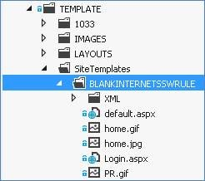

1. Package the site template’s **definition**XML file to map location “**{SharePointRoot}\TEMPLATE\1033\XML**”.  
   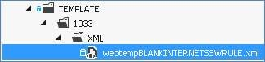
2. Deploy the package.
3. Try to upgrade to SharePoint 2013 UI again.

## Do you know how to identify customizations on SharePoint webs?

To do a successful migration, you must find all the customizations in your current environment.

* Use the command **"stsadm.exe -o enumallwebs -includefeatures -includewebparts >C:\checkcustomizations.txt"** to list all the features and web parts on webs.
* Run this command on both your current Production environment and Test migration environment to get the list of features and web parts.  
  
* Use text comparison tool, such as BeyondCompare or WinDiff, to compare your Production environment to your Test migration environment list to identify custom features and web part.
* Go to Central Admin site to check which custom WSP package has been deployed
* Go to Central Admin site 🡪 System Settings 🡪 Manage farm solutions, to look for deployed custom solution package.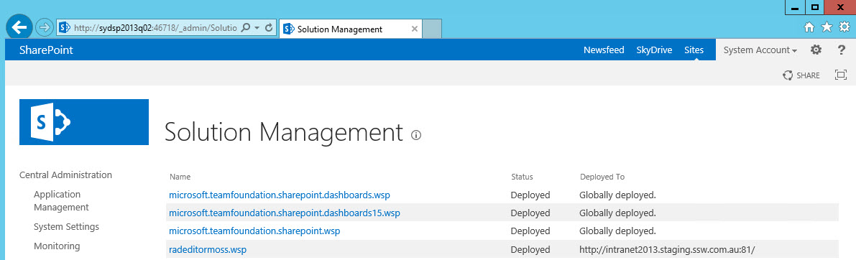
* Compare web.config files between Production and Test environment as well as to identify custom controls.

## How to deploy the imported solutions to the new site collection?

Solutions must be deployed to the new site collection **before** the content database is resorted to the SharePoint 2010/2013 server:

Open **SharePoint Central Administration** 🡪 **System Settings** 🡪 **Manage Farm Solutions**

1. Click on Deploy Solution
2. Refer to the table you completed in the rule Do you confirm your list of installed Solutions and deploy the solutions to the same site collections they were deployed to on the SharePoint 2007 server.

## Inform staff members that you are about to perform a migration

Email the staff members advising a migration is about to take place and they will not be able to check in or edit documents and should expect errors if they do so.

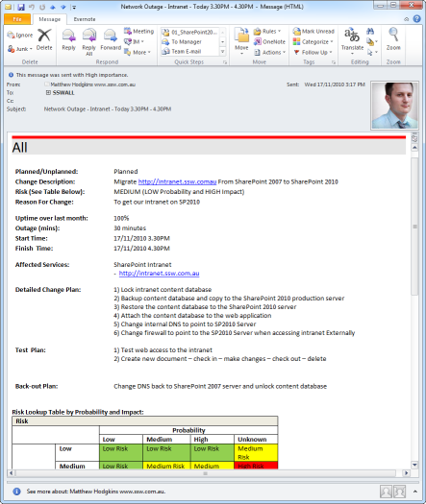

**Figure** - Send your staff an email warning of the outage. Do we know how to send a good network outage email?

## Don't Forget to lock the SharePoint Content Database before making a backup?

Even though you have advised staff members a migration is taking place – we can guarantee someone will try to check-in or edit documents. The best way to prevent this is to put your content database into read-only mode.

1. On your database server open **SQL Server Management Studio**.
2. Right click on the content database associated with the site collection your migrating 🡪 **Properties**.
3. Choose **Options** 🡪 Scroll to the bottom of the options list
4. For the **Database Read-Only** choose **True.  
   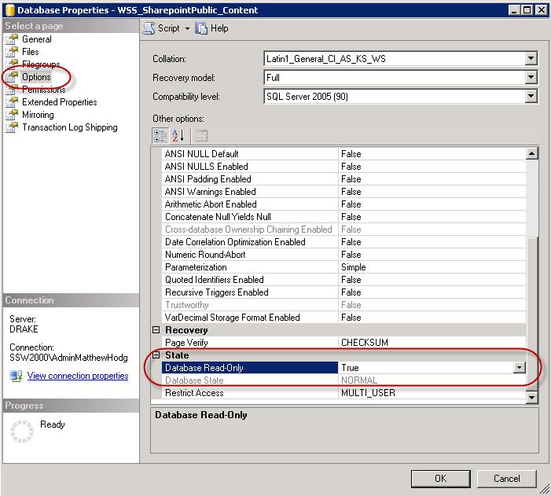  
   Figure - Database Properties 🡪 Options 🡪 Database-Read Only**
5. Now it’s safe to take a backup of your content database.

**Note:** When some SharePoint timer services are running it may cause the site to display errors when the database is in read-only mode.

## check for errors after the migration process

After the database has finished being attached to the web application you will get a log file with information about the import process.

Open this log fine and pay special attention to any lines with **[ERROR]**.

Note #1: The most common reason for errors is that you have forgotten to activate a feature.

Note #2: If you have your own custom solutions, show this file to your developers to ensure it isn’t your custom solution causing the errors.

* Check your Application Event log after migration for errors related to your SharePoint Web Application and fix those accordingly.  
  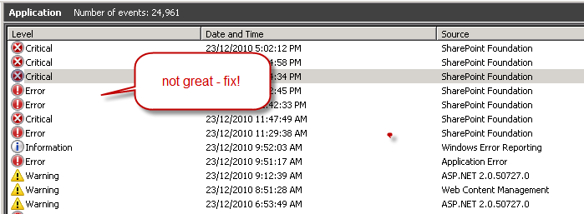**figure:** the event log should show 0 errors after fixing the errors

# Pre-Migration Analysis

* Find and remove “Orphaned Users”
* Remove empty SharePoint Groups
* Put users with explicit permissions back into Groups
* Delete any Unused Content Types, Site Columns and Workflows
* Find sites that haven’t been modified in over a year, and see if you still need them
* Ask users to check-in any document currently checked-out (ensure you migrate the latest version)
* Remove duplicate content
* Clean up items containing too many custom permissions
* Remove unwanted versions from your version history
* Reorganize Lists and Libraries with too many columns
* Complete or break running workflow instances.

# Checklist

* Content databases
* Service Applications
* Farm/Web Applications
* Farm Settings
* List down all the Customization
* Plan upgrade performance

# Questions

* Do we have workflows in SP 2010? Workflow migration does not support because SP 2010 workflow built on WWF3 and SP 2013 built on WWF4.
* More than 5000 site collections in a database, consider breaking them out in multiple databases.
* Some site and templates not available in SP 2013
* Mismatch in authentication: Claims-based authentication is the default authentication method for web applications in SharePoint 2013. If the web application was using classic mode, you can either update it to claims before you upgrade the database or create the web application in classic mode and then migrate it to claims.
* Which services we use in SP 2010

# Migrate Static Configuration

* Install and configure SP 2013 environment
* Verify authentication in SP 2010 site and create same SP 2013 site with the same authentication.
* Migrate static configuration from SP 2010 to SP 2013 like Web.config parameters, service level, and central admin level configuration.

# Migrate Custom Solution

## Approach 1: Upgrade SharePoint 2010 solution in visual studio.

* This is applicable if we are in development mode and still, we want to further enhance our product or solution.
* Create SP 2013 development environment, install SP 2013, VS 2013, configure required services, install required custom component like Ajax control toolkit, MS enterprise library etc
* Create a new blank solution in SP 2013, Move SP 2010 solution in SP 2013. Create a separate branch in TFS for future development in SP 2013.
* Create SP 2013 site with required authentication.
* Deploy custom solution on the newly created site.
* Detach content DB from SP 2010 content DB.
* Attach content DB to SP 2013 site on which we had created recently. We can attach the database using central admin.
* Test attached content DB using PowerShell command. It will display a list of custom features which are not installed on SP 2013 farm. Resolve all the issues. Verify log files or windows log. Eventvwr
* Upgrade site collection from central admin. Done.

Summary: **Deploy SharePoint 2010 Solutions in SharePoint 2013, How to Deploy SharePoint 2010 Solution in 15 Hive, Deploying SharePoint 2010 WSPs in SharePoint 2013, Migrating Custom Wsp Solutions to SharePoint 2013**

In this post, we will discuss some of the Important things to note while deploying SharePoint 2010 Solutions in SharePoint 2013. These results are based on Our experiences and findings from various posts about migration around the web.

Deploy SharePoint 2010 Solutions in SharePoint 2013.

## Approach 2

First, you need to back up your Farm Solutions from your old SharePoint instance by going to your SharePoint 2010 Central Administration -> Backup and Restore then perform a backup.

[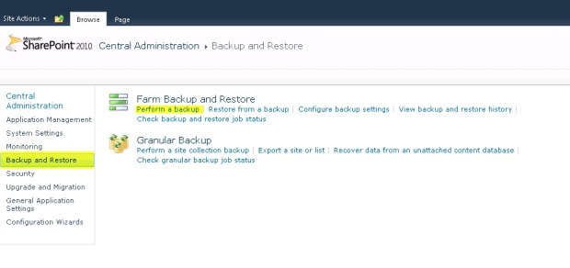](http://anyrest.files.wordpress.com/2013/10/01-backup-solutions.jpg)

Choose all the Solutions, it will pick all solutions from the list.  If you plan on migrating several but not all still do this method as the import on 2013 will ask you first what solution would you want to import.

[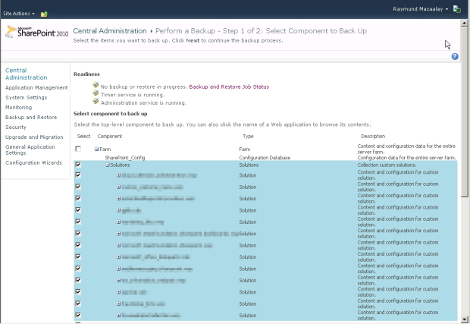](http://anyrest.files.wordpress.com/2013/10/02-choose-a-solution.jpg)

Hit next then double-check the following items, you need to also indicate the Backup location.  Then when you are ready click Start Backup.

[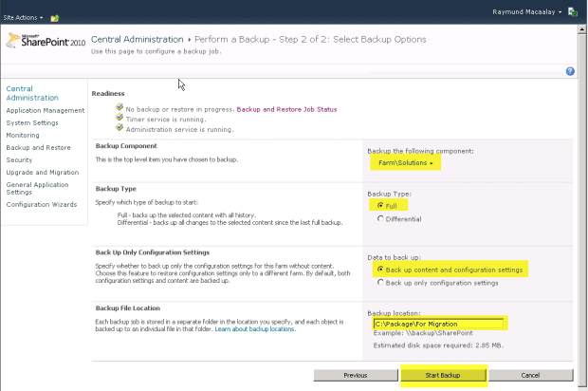](http://anyrest.files.wordpress.com/2013/10/03-settings-for-backup.jpg)

Back up now commences.

[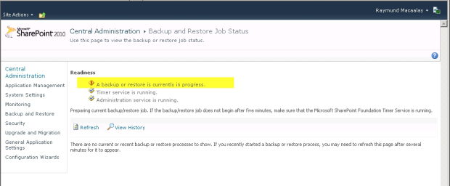](http://anyrest.files.wordpress.com/2013/10/04-backing-up.jpg)

Once finished it will tell you the result and fingers crossed it will be all OK, it will show you what folder it created on your Backup location.

[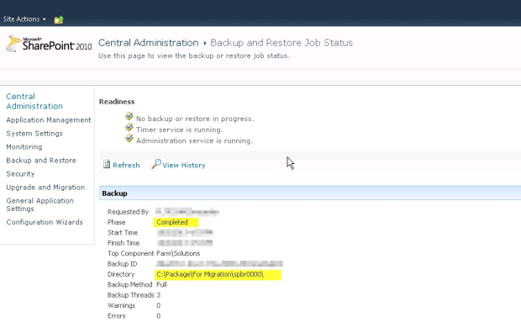](http://anyrest.files.wordpress.com/2013/10/05-backup-finished.jpg)

Verify that by going to the folder, at this point your solutions are fully backed up

[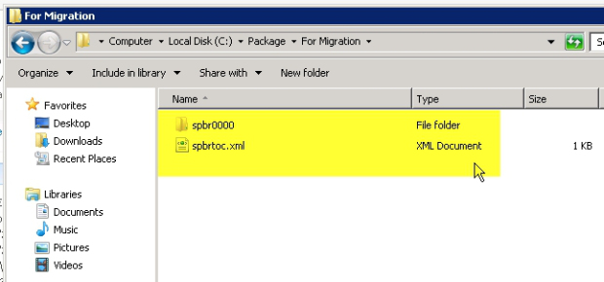](http://anyrest.files.wordpress.com/2013/10/05a-backup-finished.jpg)

Now let’s restore it, go to your SharePoint 2013 Central Administration -> Backup and Restore then click “restore from a backup”

[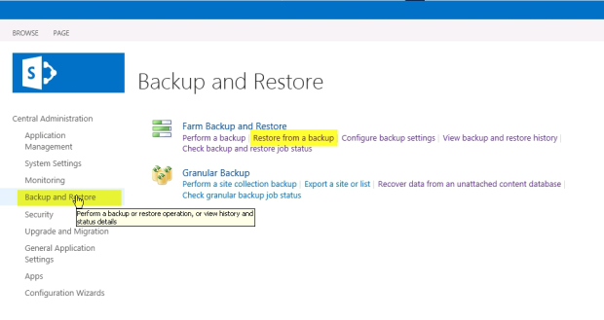](http://anyrest.files.wordpress.com/2013/10/06-restore-process.jpg)

Choose the Backup Directory Location you placed your backup click refresh, then select the solutions.  Click Next.

[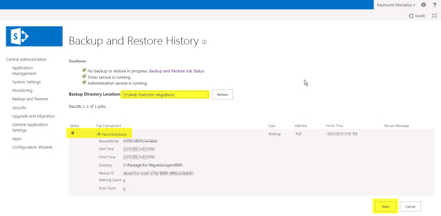](http://anyrest.files.wordpress.com/2013/10/07-restore-properties.jpg)

Choose what you want to restore, you can click the Solutions and it will include everything or you can choose one child not multiple.  Then go next.

[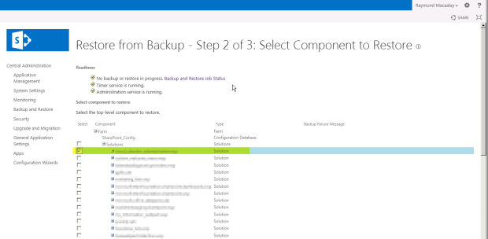](http://anyrest.files.wordpress.com/2013/10/08-choose-what-to-restore.jpg)

Check the following details presented to you.  For data to restore we need both content and configuration than for the type of restore we use the new configuration.  Click Start Restore when you are ready

[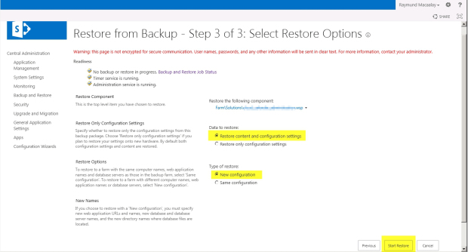](http://anyrest.files.wordpress.com/2013/10/09-restore-options.jpg)

So, if you are like me and forgot to add the permissions for the account SharePoint 2013 is using on the folder you placed your backup then you will be presented with this error

 ” Access to the path XXX is denied for the account XXX.  Ensure that the SharePoint Timer service and Microsoft SQL Server service accounts have Full Control permission on both the file share and underlying folder”

[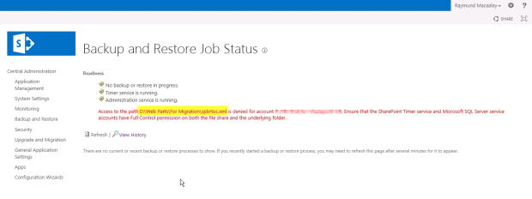](http://anyrest.files.wordpress.com/2013/10/10-make-sure-about-user-security.jpg)

Fix that by giving “**Full Permission**” on the folder then you have to go back to the restore step one.  Once all ok then it should start restoring.

[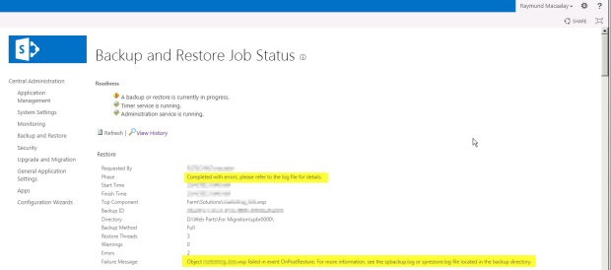](http://anyrest.files.wordpress.com/2013/10/11-error-message.jpg)

Once completed you might encounter some issues like I did on mine.  You have to check it and adjust accordingly, the error on mine was the following.

http://www.codeproject.com/images/minus.gif Collapse | [Copy Code](http://www.codeproject.com/Articles/663460/Migrating-Sharepoint-Custom-Farm-Solutions-to)

Cannot locate class information for: Microsoft.SharePoint.Diagnostics.DiagnosticLog, Microsoft.SharePoint.Diagnostics.ExtendedDiagnosticProviders, Version=1.0.0.0, Culture=neutral, PublicKeyToken=425dfe2b2d249462.

Cannot locate class information for: Microsoft.ReportingServices.SharePoint.Common.SPRSDiagnosticsService, Microsoft.ReportingServices.SharePoint.Common, Version=10.0.0.0, Culture=neutral, PublicKeyToken=89845dcd8080cc91.

I just disregarded that as I am not using DiagnosticLog for the moment as well as Reporting Services on this new SharePoint instance.  This is not related to my solution that I just restored.

After that, you just go to the Solution Management are in Central administration and you will see your solutions imported but not deployed

[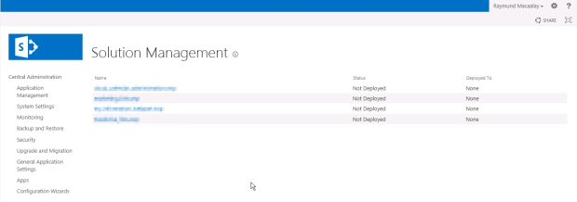](http://anyrest.files.wordpress.com/2013/10/12-solutions-added.jpg)

You can deploy them by going to each one then clicking on “Deploy Solution”

[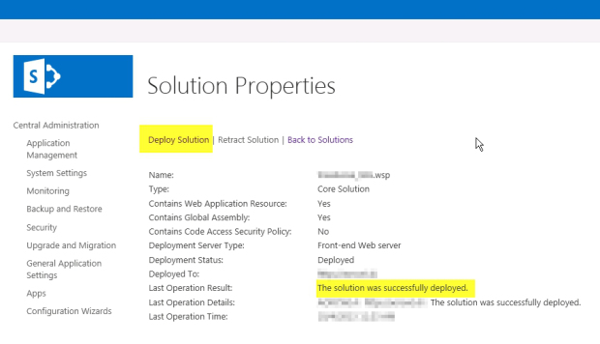](http://anyrest.files.wordpress.com/2013/10/13-deploy.jpg)

Once done for all it will have a Deployed Status.

[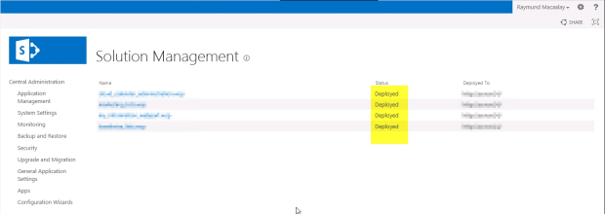](http://anyrest.files.wordpress.com/2013/10/14-all-deployed.jpg)

You can now start testing your pages with custom solutions and it should work as normal.

## Some Caveats

1. **You page with the custom code will not work if you haven’t allowed server-side scripts. To do that check this post it still works for SharePoint 2013** [http://macaalay.com/2010/10/21/how-to-enable-code-blocks-in-SharePoint-2010-works-also-in-2007/comment-page-1/](http://macaalay.com/2010/10/21/how-to-enable-code-blocks-in-sharepoint-2010-works-also-in-2007/comment-page-1/)
2. **If you have added web config items manually you have to add them again in new SharePoint.**  
   [http://www.codeproject.com/Articles/663460/Migrating-SharePoint-Custom-Farm-Solutions-to](http://www.codeproject.com/Articles/663460/Migrating-Sharepoint-Custom-Farm-Solutions-to)

# Migrating Custom WSP Solutions

Most of the wsp Solutions deployed in SharePoint 2010 should work fine in SharePoint 2013. This is because of the Support for both 14 Hive and 15 Hive directories that are Created in SharePoint 2013 by default.

Initially, when you deploy a SharePoint 2010 Solution it gets deployed to 14 Hive and not 15 Hive. To force the solution to install in 15 Hive you need to modify a manifest.xml file of your solution and add add*SharePointVersion=”15.0″* attribute to it. The Solutions can be forced to install in 15 hive that way However, some of the files especially that refers to _layouts might not work. All SharePoint 2010 Solution files that refer to a _layouts folder (i.e. Features, Layouts-files, Images, ControlTemplates) needs to be updated (best approach is to Re-Create the Solution in Visual Studio 2013). In 15 hive, files in Layouts directory has a Path with ’15’ added to it.

For example, the path of a Custompage in 14 and 15 hive would be –

14 Hive path  – _/layouts/Custompage.aspx  
15 Hive  path – _/layouts/**15**/Custompage.aspx

Notice the reference of 15 in _layouts folder reference in 15 Hive. This is the reason you need to update paths of all the deployed files such as Features, Layouts-files, Images, ControlTemplates if the solutions are targeted to be deployed in 15 Hive.

[**Compatibility Level**](http://www.learningsharepoint.com/2012/10/31/sharepoint-2013-deploy-solutions-to-14-and-15-hive-with-install-spsolution/)**-** In addition to *SharePointVersion=”15.0″*attribute, with the new “CompatabilityLevel” parameter of Install -SPSolution cmdlet you can now deploy your .wsp or Solution to either 14 hive, 15 hive or both using the Powershell itself. This “Compatibility Level” value overrides SharePointProductVersion specified in the manifest of the solution and it is the only way with which solutions can be installed in both 14 & 15 Hive.

Compatibility Level Impacts only files deployed to the Templates folder in the 14/15 Root folder i.e. Features, Layouts-files, Images, ControlTemplates, etc. The files deployed Outside of this folder (e.g. a WCF Service) will be deployed to the 15/ISAPI regardless of the Manifest or PowerShell Compatibility level settings of the wsp-package. Files such as Assemblies in GAC/Bin and certain resource files will also be deployed to the same location regardless of the Compatibility Level.

**Bin Directory Considerations -**  
Also, you can no longer add partial trust solution packages to the \bin directory. Any files deployed to the \bin directory must be full trust.

**GAC Considerations -** After the Release of .NET Framework 4.0, the GAC was split into two, one for each CLR.  
c:\windows\assembly is the location for .NET versions 1.0 through 3.5 and  
c:\windows\microsoft.net\assembly is the location for all the dlls for project Created in .NET Framework 4.0.  
Consider looking into new Location if you have Created your project in Visual Studio 2012.

For these reasons and more it is Recommended to Re-Create a Solution in Visual Studio 2012, Re-add all the features, Components and then deploy it to SharePoint 2013 in 15 hive.

# Sandbox Solutions

Sandbox solutions are upgraded with the Content databases.

# Fabulous 40 templates in SharePoint 2013

As per MSDN, Microsoft is not Creating any New Versions of these Fabulous 40 Templates. The Old Sites based on these templates can be upgraded only if the Templates are Installed successfully in SharePoint 2013. You can try installing wsp of Fab 40 with CompatabilityLevel as 15 and upgrade the existing site collections.

# Master pages and CSS files

Master Pages and CSS has Changed a lot in SharePoint 2013. You can deploy a master page in Master page gallery but the styles from old core.css needs to be updated. See some useful tips on [How to Override default CSS in Layout and Master Pages in SharePoint 2013](http://www.learningsharepoint.com/2013/04/15/adding-style-sheets-css-in-layout-master-pages-in-sharepoint-2013/)

# Themes

Re-create your themes following the SharePoint 2013 theming guidance or select a new theme available in SharePoint 2013.

# Migrate OOTB features

You will need to have two servers which have the same environment:

* Server 1: Windows 2008; SQL Server 2008; SharePoint 2010.
* Server 2: Windows 2008; SQL Server 2008; SharePoint 2013.

**Back up your content Database in SharePoint 2010 and restore it in SharePoint 2013 in just five steps:**

1. **Back up your database from SharePoint 2010 Server through SQL Server 2008**
   * Right-click the database of the port which you want to back up, then **Tasks**🡪**Back** **Up**
   * See the example below; the database of port 80 is WSS_Content:  
     [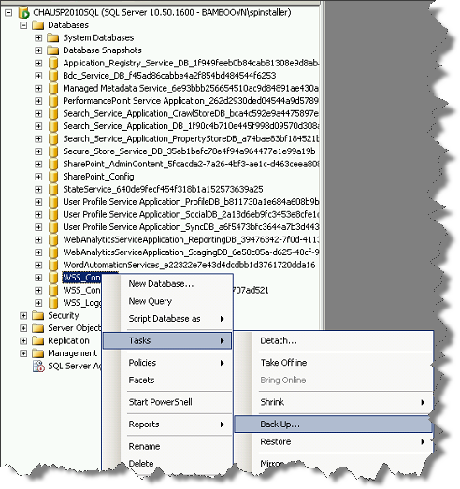](http://community.bamboosolutions.com/cfs-file.ashx/__key/CommunityServer.Blogs.Components.WeblogFiles/sharepoint-2013/91.png)
   * Please double check the Database which we have selected in the Popup we have to select the appropriate database name which we have to take Back Up.
   * Click the **Add** button.  
     Make sure you note the “Destination path” to get the **WSS_Content.bak** file:  
     [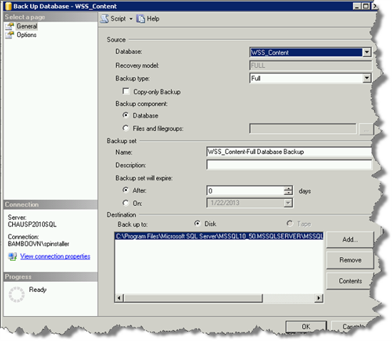](http://community.bamboosolutions.com/cfs-file.ashx/__key/CommunityServer.Blogs.Components.WeblogFiles/sharepoint-2013/92.png)
2. **Create a new Web application on SharePoint 2013 server**
   * Create a new Web application with any port (Example: port 88)  
     (We also have added steps in User Guide for Creating New Web Application in SharePoint 2013)
   * After the new Web application has been successfully created, go to Central Administration -> Application Management -> Manage content databases, and remove the current database of the newly created Web application:  
     [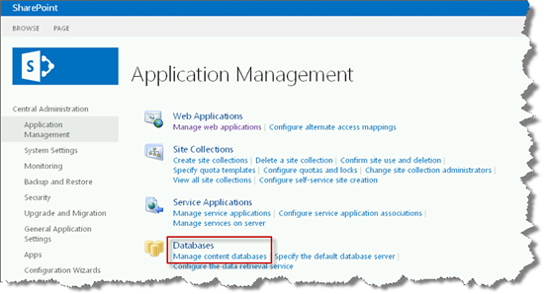](http://community.bamboosolutions.com/cfs-file.ashx/__key/CommunityServer.Blogs.Components.WeblogFiles/sharepoint-2013/93.png)
   * Select the Remove content database Checkbox. Click OK and Save buttons:  
     [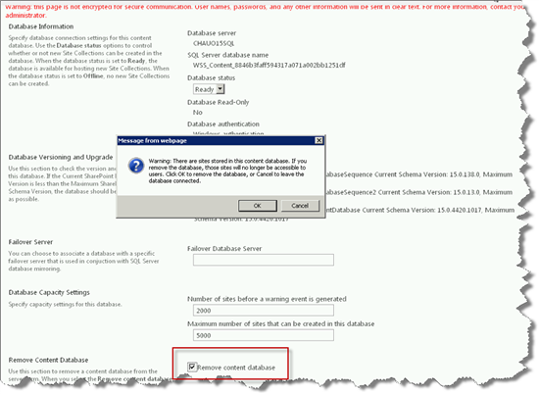](http://community.bamboosolutions.com/cfs-file.ashx/__key/CommunityServer.Blogs.Components.WeblogFiles/sharepoint-2013/94.png)
   * After you have removed the content database, Content Database should show that "There are no items to show in this view," as pictured below:  
     [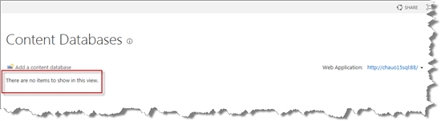](http://community.bamboosolutions.com/cfs-file.ashx/__key/CommunityServer.Blogs.Components.WeblogFiles/sharepoint-2013/95.png)
3. **Restore your database to the SharePoint 2013 server:**
   * Copy the WSS_Content.bak file in the SharePoint 2010 Server to your SharePoint 2013 Server. Select your source and destination as follows:  
     [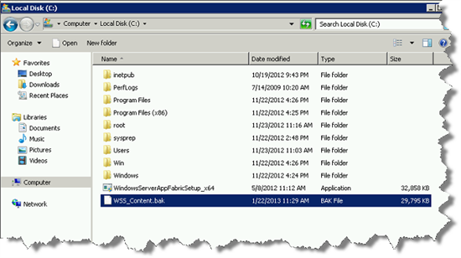](http://community.bamboosolutions.com/cfs-file.ashx/__key/CommunityServer.Blogs.Components.WeblogFiles/sharepoint-2013/96.png)
   * Open SQL Server 2008 in SharePoint 2013 Server, right-click the **Database** node, and select **Restore** **Database**:  
     [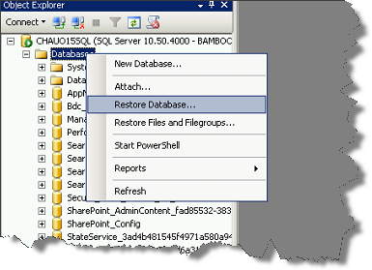](http://community.bamboosolutions.com/cfs-file.ashx/__key/CommunityServer.Blogs.Components.WeblogFiles/sharepoint-2013/97.png)
   * Input the Database Name and select the **from** **device** radio button:  
     [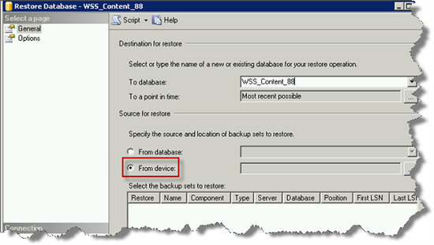](http://community.bamboosolutions.com/cfs-file.ashx/__key/CommunityServer.Blogs.Components.WeblogFiles/sharepoint-2013/98.png)
   * Browse to the .bak file which you copied from SharePoint 2010 Server in SharePoint 2013 Server (in this example, we are using the file WSS_Content.bak):  
     [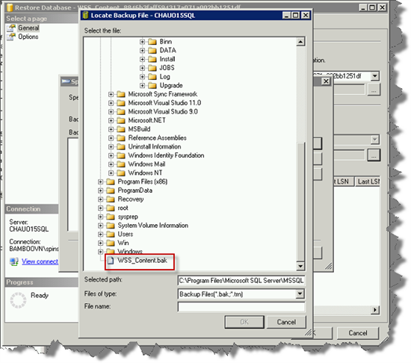](http://community.bamboosolutions.com/cfs-file.ashx/__key/CommunityServer.Blogs.Components.WeblogFiles/sharepoint-2013/99.png)
   * Click **OK**:  
     [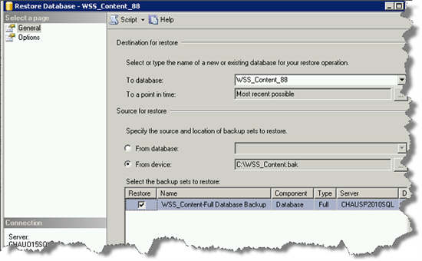](http://community.bamboosolutions.com/cfs-file.ashx/__key/CommunityServer.Blogs.Components.WeblogFiles/sharepoint-2013/101.png)
   * Select the **Options** tab. Next, select the **Overwrite the existing database** Checkbox. Click **OK**:  
     [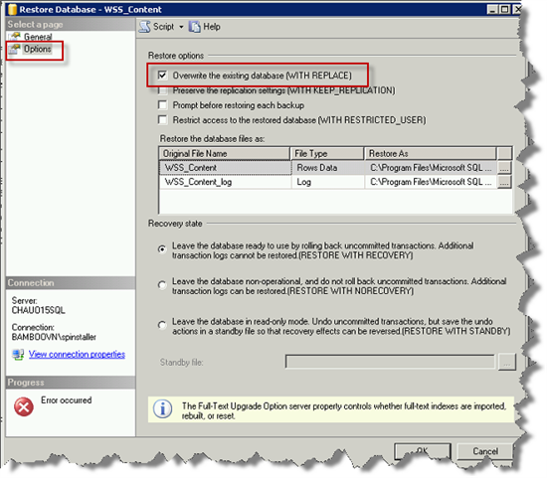](http://community.bamboosolutions.com/cfs-file.ashx/__key/CommunityServer.Blogs.Components.WeblogFiles/sharepoint-2013/102.png)
   * A dialog box will appear that states that your restore was successful:  
     [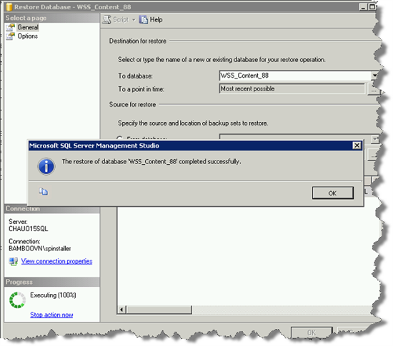](http://community.bamboosolutions.com/cfs-file.ashx/__key/CommunityServer.Blogs.Components.WeblogFiles/sharepoint-2013/103.png)

**Note:** After Completely Restore of the Database we have to Make Minor Changes for making it available for the Web Applications. For that, we just make our database “read only = false”, Follow the Further steps for making it Available and change it's “Read Only State from true to false”. (If its note in Read Only mode than we don’t have to follow these steps)

1. On your database server open **SQL Server Management Studio**.
2. Right click on the content database associated with the site collection your migrating 🡪 **Properties**.
3. Choose **Options** 🡪 Scroll to the bottom of the options list
4. For the **Database Read-Only** choose **False.  
   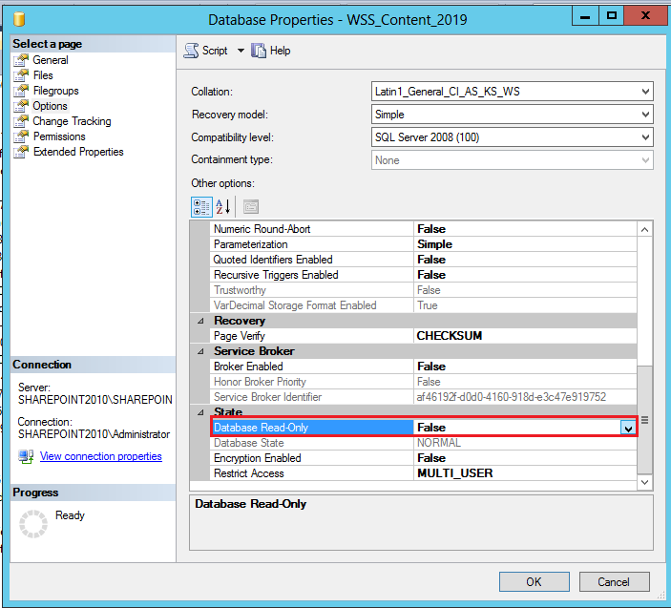  
   Figure - Database Properties 🡪 Options 🡪 Database-Read Only 🡪 false**
5. **Verifying the content database:**  
   Launch the SharePoint 2013 Management Shell and type this command:  
   As a rule of thumb, Microsoft recommends you perform a Test-SPContentDatabase before performing any upgrades to prevent issues like these from occurring.  
   Test-SPContentDatabase -Name <database name> -WebApplication <URL>  
   For example:  
   Test-SPContentDatabase -Name WSS_Content_88 -WebApplication http://chauo15sql:88  
   [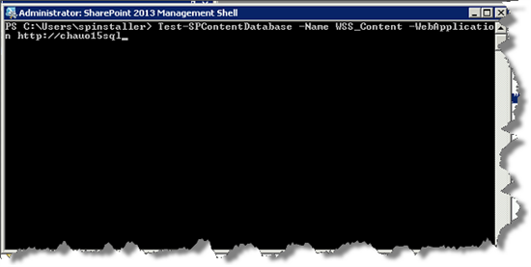](http://community.bamboosolutions.com/cfs-file.ashx/__key/CommunityServer.Blogs.Components.WeblogFiles/sharepoint-2013/104.png)[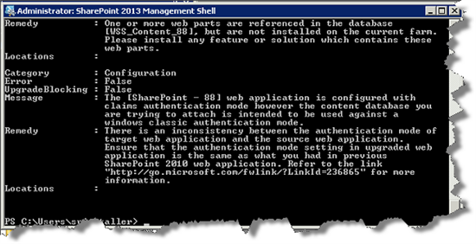](http://community.bamboosolutions.com/cfs-file.ashx/__key/CommunityServer.Blogs.Components.WeblogFiles/sharepoint-2013/105.png)
6. **Add the restored content database to the new Web application (port 88):**Run the **STSADM** command line as shown below
   * cd "C:\Program Files\Common Files\Microsoft Shared\Web Server Extensions\15\BIN\"  
     [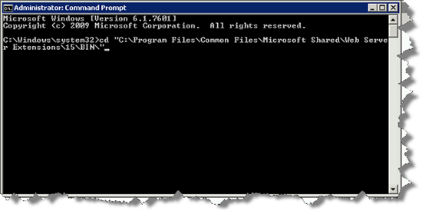](http://community.bamboosolutions.com/cfs-file.ashx/__key/CommunityServer.Blogs.Components.WeblogFiles/sharepoint-2013/106.png)  
     stsadm.exe -o addcontentdb -url <URL> -databasename <database name>  
     For example:  
     stsadm.exe -o addcontentdb -url <http://chauo15sql:88> -databasename WSS_Content_88  
     [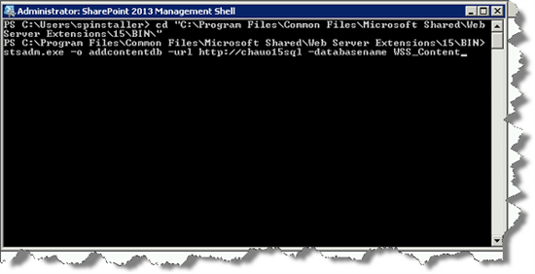](http://community.bamboosolutions.com/cfs-file.ashx/__key/CommunityServer.Blogs.Components.WeblogFiles/sharepoint-2013/107.png)  
     [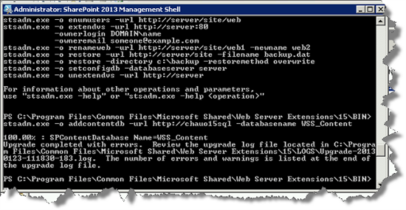](http://community.bamboosolutions.com/cfs-file.ashx/__key/CommunityServer.Blogs.Components.WeblogFiles/sharepoint-2013/108.png)
   * After the upgrade has completed successfully, go back to Central Administration 🡪 Application Management 🡪 Manage content databases, and under your content databases, you will now see the upgraded database listed under your designated Web Application:  
     [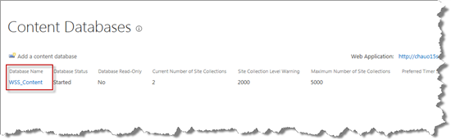](http://community.bamboosolutions.com/cfs-file.ashx/__key/CommunityServer.Blogs.Components.WeblogFiles/sharepoint-2013/109.png)
   * Go to the SharePoint 2013 site. By default, your site will retain the SharePoint 2010 theme. You will need to manually change this for 2013. This can be done by following these steps:
7. Click on the **Start now** hyperlink at the top of the site:  
   [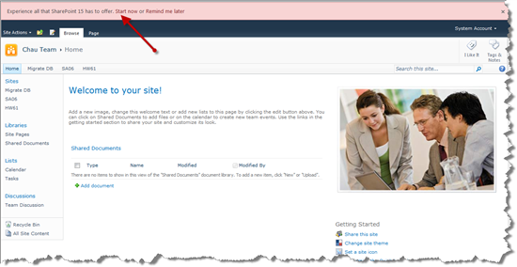](http://community.bamboosolutions.com/cfs-file.ashx/__key/CommunityServer.Blogs.Components.WeblogFiles/sharepoint-2013/110.png)
8. Click on the **Upgrade this Site Collection** button:  
   [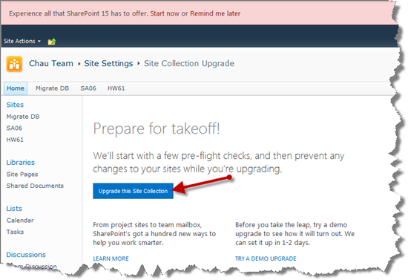](http://community.bamboosolutions.com/cfs-file.ashx/__key/CommunityServer.Blogs.Components.WeblogFiles/sharepoint-2013/111.png)
9. Click on **I'm ready**:  
   [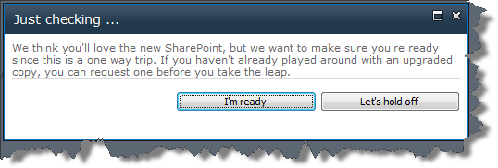](http://community.bamboosolutions.com/cfs-file.ashx/__key/CommunityServer.Blogs.Components.WeblogFiles/sharepoint-2013/112.png)
10. Once the upgrade has completed (FYI - this may take a few minutes), a dialog box will appear to let you know that the upgrade completed successfully:  
    [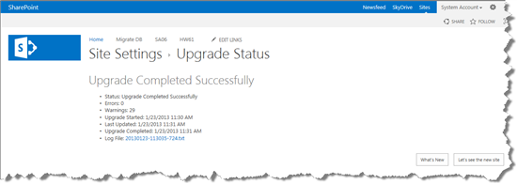](http://community.bamboosolutions.com/cfs-file.ashx/__key/CommunityServer.Blogs.Components.WeblogFiles/sharepoint-2013/113.png)
11. Rest assured that if you see the error message below in regard to your Bamboo Products that you were successful in completing the steps above! But wait, there's more...  
    [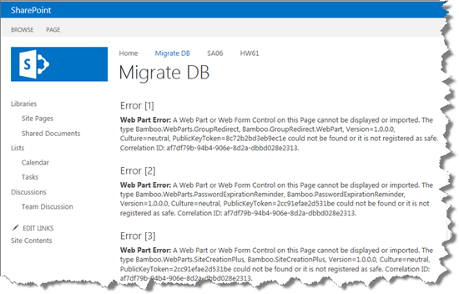](http://community.bamboosolutions.com/cfs-file.ashx/__key/CommunityServer.Blogs.Components.WeblogFiles/sharepoint-2013/114.png)  
    [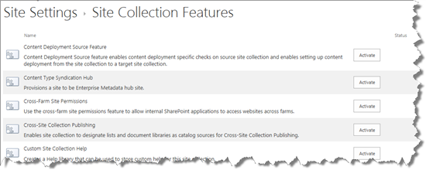](http://community.bamboosolutions.com/cfs-file.ashx/__key/CommunityServer.Blogs.Components.WeblogFiles/sharepoint-2013/116.png)
12. Before your Bamboo Products are installed on your SharePoint 2013 Server, you will need to have accepted the terms and conditions presented in the End-User Software License Agreement:  
    [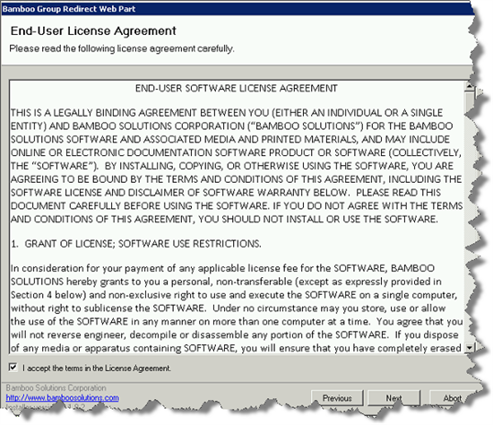](http://community.bamboosolutions.com/cfs-file.ashx/__key/CommunityServer.Blogs.Components.WeblogFiles/sharepoint-2013/117.png)
13. Once accepted, your installation is complete! You will see that now all of your Bamboo Products are activated in Site Collection Features and it's back to business as usual!  
    [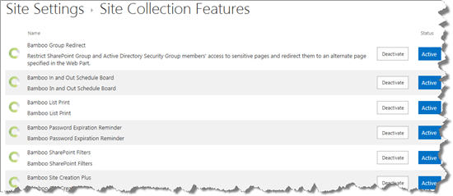](http://community.bamboosolutions.com/cfs-file.ashx/__key/CommunityServer.Blogs.Components.WeblogFiles/sharepoint-2013/118.png)  
      
    [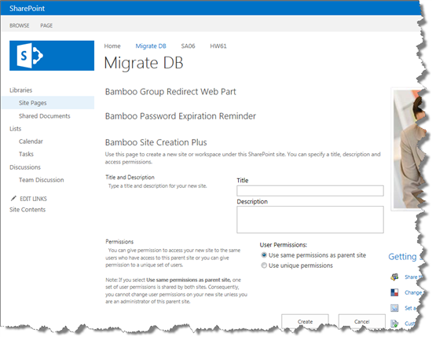](http://community.bamboosolutions.com/cfs-file.ashx/__key/CommunityServer.Blogs.Components.WeblogFiles/sharepoint-2013/119.png)

# How to troubleshoot issues related to the migration of Content DB

Browse the site collections which are in new SharePoint 2013 farm, most of the times we will see the error on the home page of site collection because of various reasons.

[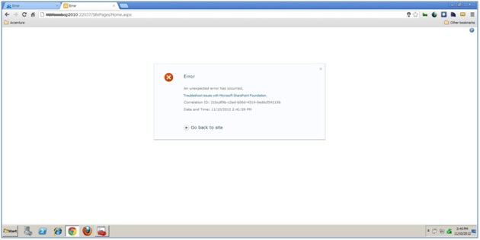](http://www.sharepoint-journey.com/images/Migrate-site-Error.jpg)

The above error represents the way of displaying it in SharePoint 2010 mode.

Whereas SharePoint 2013 error message will be different way display, please check the above Screenshot.

[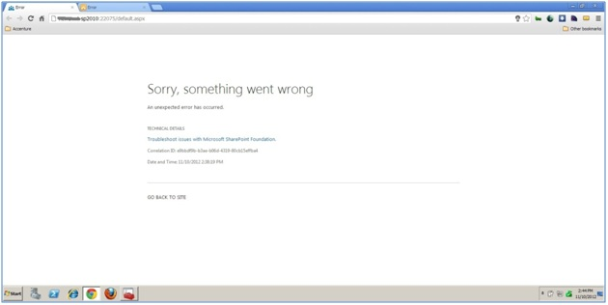](http://www.sharepoint-journey.com/images/Migrate-site-Error-SP2013.jpg)

Use “Get-SPLogevent” command to find what that error is.

Get-SPLogevent -starttime (get-date).addminutes (-20) | where-object {$_.correlation -eq “28331078-c03b-48e8-b27a-1b86ef7e5ce1”} | fl message > c:\errors.txt.

The above PowerShell command will filter the logs for the correlation Id logs that have been generated in ULS and store it in an errors.txt file in C drive.

You can use Get-help command with examples.

You can use Merge-SPLogfile command to merge the log files across the farm into a single file.

To check whether the site collection exists or go site settings page “URL”+/_layouts/settings.aspx we will see the below similar to below screenshot.

[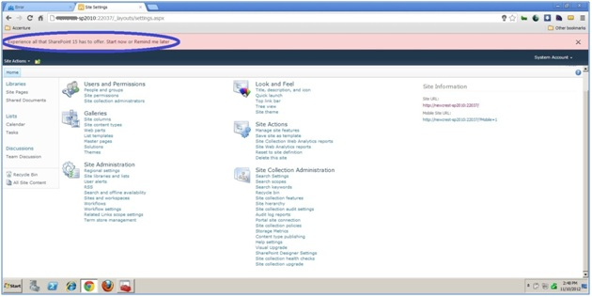](http://www.sharepoint-journey.com/images/Migrate-site-Error-SP2013-Troubleshoot.jpg)

Great now we have the migrated site from SharePoint 2010 to SharePoint 2013 farm showing in SharePoint 2010 mode.

It shows the message as “Experience all that SharePoint 15 has to offer. Start now or Remind me later”.

Under the site collection administration, we can see two new features “Site collection health checks” and “Site collection upgrade”.

[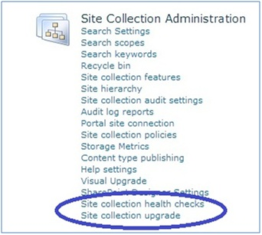](http://www.sharepoint-journey.com/images/SiteCollectionHealthChecksandupgrade.jpg)

Site collection health checks:

Click on Site collection health checks to see if there are any issues with the upgraded site collection.

From there click on “start checks” button.

[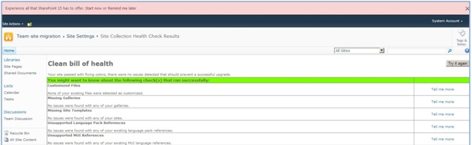](http://www.sharepoint-journey.com/images/Cleanbillofhealth.jpg)

Here in our case, we don’t see any issues. So, it is showing status in green color and it says “Clean bill of health”.

So, we are ready for an upgrade.

Site Collection Upgrade:

Click on site collection upgrade from the “Site collection upgrade “the below screen appears.

[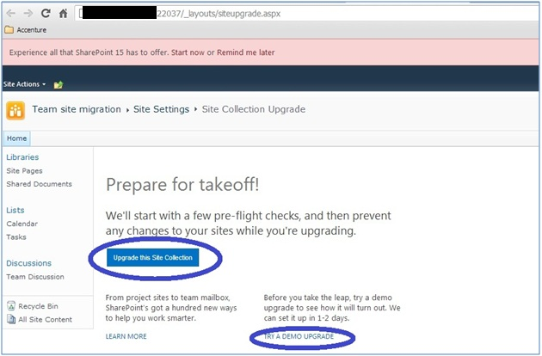](http://www.sharepoint-journey.com/images/SiteCollectionUpgrade-POC.jpg)

Click on “Upgrade this Site collection”. We can try the demo upgrade as well it will create a clone of the current site collection.

[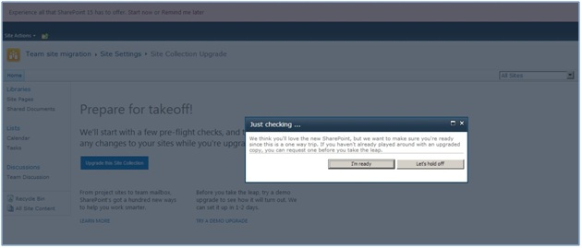](http://www.sharepoint-journey.com/images/SiteCollectionUpgrade-2-POC.jpg)

Click on I’m Ready from the above screenshot. It will start the site collection upgrade process.

[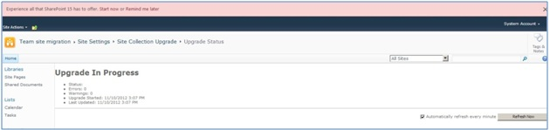](http://www.sharepoint-journey.com/images/UpgradeProcess-POC.jpg)

We can observe status as an upgrade in Progress.

Congratulations we have upgraded the site collection successfully.

[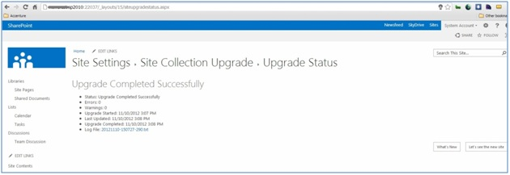](http://www.sharepoint-journey.com/images/SiteCollectionUpgradeStatus.jpg)

Congratulations you have completed the up-gradation from SharePoint 2010 to SharePoint 2013.

You can the status of migration from Central Administration.

[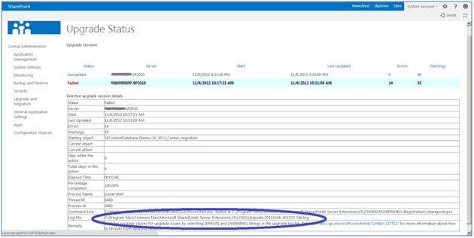](http://www.sharepoint-journey.com/images/UpgradeStatus-CentralAdmin.jpg)

To verify that upgrade has succeeded, we can review the following log and error files:

The upgrade log file and the upgrade error log file.

Review the upgrade log file and the upgrade error log file (generated when we run the upgrade). The upgrade log file and the upgrade error log files are located at %COMMONPROGRAMFILES%\Microsoft Shared\Web server extensions\15\LOGS. The logs are named in the following format: Upgrade-YYYYMMDD-HHMMSS-SSS.log, Where YYYYMMDD is the date and HHMMSS-SSS is the time (hours in 24-hour clock format, minutes, seconds, and milliseconds). The upgrade error log file combines all errors and warnings in a shorter file and is named Upgrade-YYYYMMDD-HHMMSS-SSS-error.log.

- See more here: http://www.SharePoint-journey.com/upgrade-from-SharePoint-2010-to-2013-part4.html#sthash.jxWeMefi.dpuf

<http://www.falconitservices.com/support/KB/Lists/Posts/Post.aspx?ID=124>

[http://www.SharePoint-journey.com/upgrade-from-SharePoint-2010-to-2013-part1.html](http://www.sharepoint-journey.com/upgrade-from-sharepoint-2010-to-2013-part1.html)

[http://en.share-gate.com/blog/step-by-step-upgrade-SharePoint-2010-database-to-SharePoint-2013](http://en.share-gate.com/blog/step-by-step-upgrade-sharepoint-2010-database-to-sharepoint-2013)

SharePoint 2010 to SP 2013 migration

<http://www.codeproject.com/Articles/663663/Live-Migration-of-SharePoint-to-SharePoint>

<http://www.falconitservices.com/support/KB/Lists/Posts/Post.aspx?ID=124>

<http://techdays.org/wp-content/uploads/2013/05/TD_Migration.pdf>

<http://technet.microsoft.com/en-us/library/cc303436(v=office.15).aspx>

Visual studio 2010 upgrade for SP 2013

1. Download officetools_bundle from this direct link <http://go.microsoft.com/fwlink/?LinkID=279063&clcid=0x409>
2. [http://yalla.itgroove.net/2012/08/30/SharePoint-2013-project-templates-for-visual-studio-2012/](http://yalla.itgroove.net/2012/08/30/sharepoint-2013-project-templates-for-visual-studio-2012/)